**LAB 2-3:**

**Feedback(Lab2-3)**

Github:https://github.com/kotadakshata15924/FEWD.git

(feedback2-3.html)

<!DOCTYPE html>

<html lang="en">

<head>

<meta charset="UTF-8">

<meta name="viewport" content="width=device-width, initial-scale=1.0">

<title>Feedback Form</title>

<link rel="stylesheet" href="style.css"> <!-- Linking External CSS -->

</head>

<body>

<div class="container">

<h2>Feedback Form</h2>

<form>

<label for="name">Name (Optional):</label>

<input type="text" id="name" name="name" placeholder="Enter your name">

<label for="email">Email (Optional):</label>

<input type="email" id="email" name="email" placeholder="Enter your email">

<label for="phone">Phone (Optional):</label>

<input type="tel" id="phone" name="phone" placeholder="Enter your phone number">

<label for="rating">Rating:</label>

<select id="rating" name="rating" required>

<option value="" disabled selected>Select rating</option>

<option value="5">⭐⭐⭐⭐⭐ - Excellent</option>

<option value="4">⭐⭐⭐⭐ - Good</option>

<option value="3">⭐⭐⭐ - Average</option>

<option value="2">⭐⭐ - Poor</option>

<option value="1">⭐ - Very Bad</option>

</select>

<label for="question">Any Questions regarding product/service:</label>

<textarea id="question" name="question" rows="3" placeholder="Write your question here..." required></textarea>

<label for="comments">Additional Comments (Optional):</label>

<textarea id="comments" name="comments" rows="3" placeholder="Any additional feedback?"></textarea>

<button type="submit">Submit Feedback</button>

</form>

</div>

</body>

</html>

(feedback2-3.css)

/* Reset default margin & padding */

* {

margin: 0;

padding: 0;

box-sizing: border-box;

}

body {

font-family: Arial, sans-serif;

background-color: #f4f4f4;

color: #333;

}

.container {

width: 50%;

margin: auto;

background: white;

padding: 20px;

margin-top: 50px;

border-radius: 10px;

box-shadow: 0 0 10px rgba(0, 0, 0, 0.1);

}

h2 {

text-align: center;

color: #444;

margin-bottom: 20px;

}

label {

font-weight: bold;

display: block;

margin-top: 10px;

}

input, textarea, select {

width: 100%;

padding: 10px;

margin-top: 5px;

border: 1px solid #ccc;

border-radius: 5px;

}

button {

width: 100%;

background: #007BFF;

color: white;

padding: 10px;

border: none;

border-radius: 5px;

cursor: pointer;

font-size: 16px;

margin-top: 15px;

}

button:hover {

background: #0056b3;

}

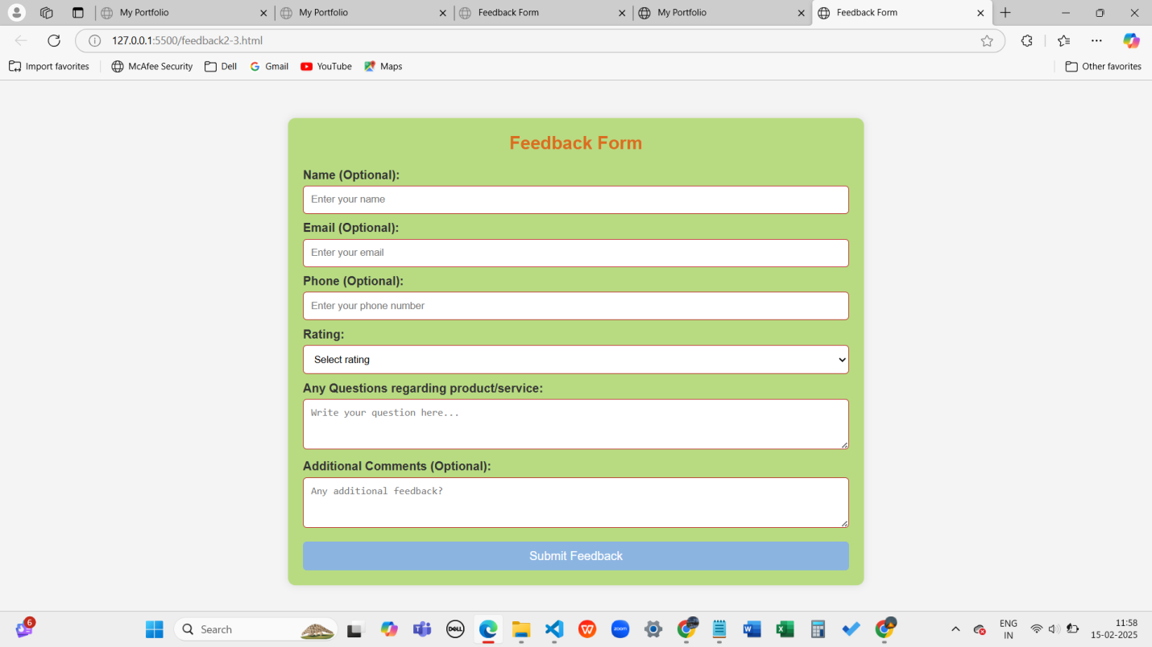

**Portfolio(Lab 2-3)**

Github:https://github.com/kotadakshata15924/FEWD.git

(portfolio2-3.html)

<!DOCTYPE html>

<html lang="en">

<head>

<meta charset="UTF-8">

<meta name="viewport" content="width=device-width, initial-scale=1.0">

<title>My Portfolio</title>

<link rel="stylesheet" href="style.css"> <!-- Linking External CSS -->

</head>

<body>

<header>

<h1>My Portfolio</h1>

</header>

<div class="container">

<section id="about">

<h2>Self Introduction</h2>

<p>Hello! I'm <strong>Dakshata</strong>, a passionate software engineer with expertise in web development,PowerBI, cloud computing, and DevOps.</p>

</section>

<section id="skills">

<h2>Skills</h2>

<ul>

<li>HTML, CSS, JavaScript</li>

<li>React, Node.js</li>

<li>Docker, Kubernetes, AWS</li>

<li>Maven, Jenkins, Nagios</li>

</ul>

</section>

<section id="projects">

<h2>Projects / Work Experience</h2>

<ul>

<li><a href="https://github.com/your-profile/project1" target="_blank">Project 1</a></li>

<li><a href="https://github.com/your-profile/project2" target="_blank">Project 2</a></li>

</ul>

</section>

<section id="feedback">

<h2>Feedback / Achievements</h2>

<p>Received 'Best Developer' award in [Year]. Contributed to open-source projects with over 500+ stars.</p>

</section>

<section id="education">

<h2>Education Profile</h2>

<p>Bachelor's in Computer Science - KMIT University</p>

</section>

<section id="contact">

<h2>Contact Information</h2>

<div class="contact">

<a href="mailto:your.email@example.com">Email: your.email@example.com</a>

<a href="tel:+91 93734675">Phone: +91234567890</a>

<a href="https://linkedin.com/in/yourprofile" target="_blank">LinkedIn</a>

<a href="https://github.com/your-profile" target="_blank">GitHub</a>

</div>

</section>

</div>

</body>

</html>

(portfolio2-3.css)

* {

margin: 0;

padding: 0;

box-sizing: border-box;

}

body {

font-family: Arial, sans-serif;

background-color: #f4f4f4;

color: #333;

}

.container {

width: 80%;

margin: auto;

overflow: hidden;

}

header {

background: #333;

color: white;

padding: 20px 0;

text-align: center;

}

section {

background: white;

padding: 20px;

margin: 20px 0;

border-radius: 10px;

box-shadow: 0 0 10px rgba(0, 0, 0, 0.1);

}

h2 {

color: #444;

margin-bottom: 10px;

}

ul {

list-style-type: square;

margin-left: 20px;

}

.contact a {

display: block;

text-decoration: none;

color: #007BFF;

margin: 5px 0;

}

.contact a:hover {

text-decoration: underline;

}

